**Assignment - 4**

**Wowki & IBM Cloud**

| **Assignment Date** | 30 October 2022 |
| --- | --- |
| **Student Name** | Lakshya P |
| **Student Roll Number** | 713119106005 |
| **Maximum Marks** | 2 Marks |

Question-1:

Write code and connections in wowki for the ultrasonic sensor. Whenever the distance is less than 100cms sent "alert" to IBM cloud and display in device recent events.

Code:

#include <WiFi.h>

#include <PubSubClient.h>

#include <ArduinoJson.h>

WiFiClient wifiClient;

#define ORG "oa3490"

#define DEVICE_TYPE "TestDeviceType"

#define DEVICE_ID "12345"

#define TOKEN "-A)0raS44f)fdjYBVS"

#define speed 0.034

char server[] = ORG ".messaging.internetofthings.ibmcloud.com"; char publishTopic[] = "iot-2/evt/abcd_1/fmt/json"; char topic[] = "iot-2/cmd/home/fmt/String"; char authMethod[] = "use-token-auth"; char token[] = TOKEN;

char clientId[] = "d:" ORG ":" DEVICE_TYPE ":" DEVICE_ID; PubSubClient client(server, 1883, wifiClient); void publishData();

const int trigpin=5;

const int echopin=18; String command;

String data="";

String lat="14.167589";

String lon="80.248510";

String name="point2"; String icon="";

long duration; int dist;

void setup()

{ **Serial**.begin(115200) ; pinMode(trigpin, OUTPUT) ; pinMode(echopin, INPUT) ; wifiConnect(); mqttConnect();

}

void loop() {

publishData(); delay(500) ;

if (!client.loop()) {

mqttConnect();

} }

void wifiConnect() {

**Serial**.print("Connecting to "); **Serial**.print("Wifi") ; WiFi.begin("Wokwi-GUEST", "", 6) ; while ( WiFi.status() != WL_CONNECTED) {

delay(500) ; **Serial**.print(".") ;

}

**Serial**.print("WiFi connected, IP address: ") ;

**Serial**.println( WiFi.localIP());

}

void mqttConnect() {

if (! client.connected()) {

**Serial**.print("Reconnecting MQTT client to ") ;

**Serial**.println( server); while (!client.connect(clientId, authMethod, token)) { **Serial**.print(".") ; delay(1000) ;

}

initManagedDevice(); **Serial**.println() ;

} }

void initManagedDevice() {

if ( client.subscribe(topic)) {

**Serial**.println( client.subscribe(topic));

**Serial**.println("subscribe to cmd OK") ;

} else {

**Serial**.println("subscribe to cmd FAILED") ;

} } void publishData()

{ digitalWrite(trigpin,LOW) ; digitalWrite(trigpin,HIGH) ; delayMicroseconds(10) ; digitalWrite(trigpin,LOW) ; duration=pulseIn(echopin,HIGH) ; dist=duration*speed/2;

if(dist<100){

dist=100- dist; icon="fa-trash";

}else{ dist=0; icon="fa-trash-o";

}

DynamicJsonDocument doc(1024) ; String payload; doc["Name"]= name; doc["Latitude"]= lat; doc["Longitude"]= lon; doc["Icon"]= icon; doc["FillPercent"]= dist; serializeJson(doc, payload); delay(3000) ; **Serial**.print("\n") ;

**Serial**.print("Sending payload: ") ; **Serial**.println( payload);

if (client.publish(publishTopic, (char*) payload.c_str())) { **Serial**.println("Publish OK") ;

} else {

**Serial**.println("Publish FAILED") ;

}

}

**Connections:**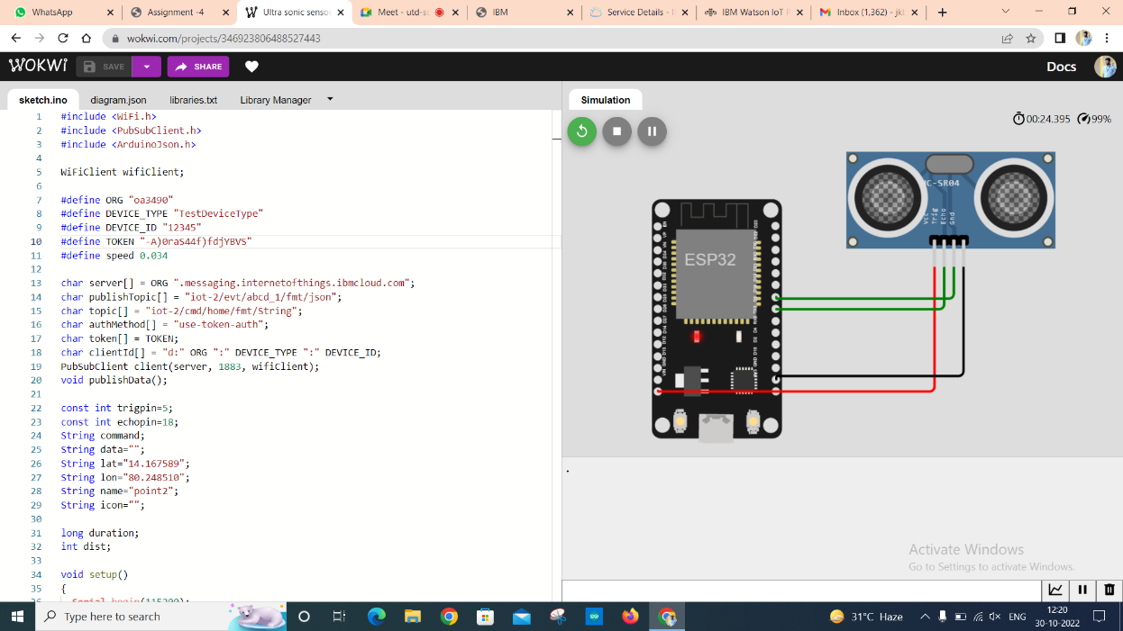

**Output:**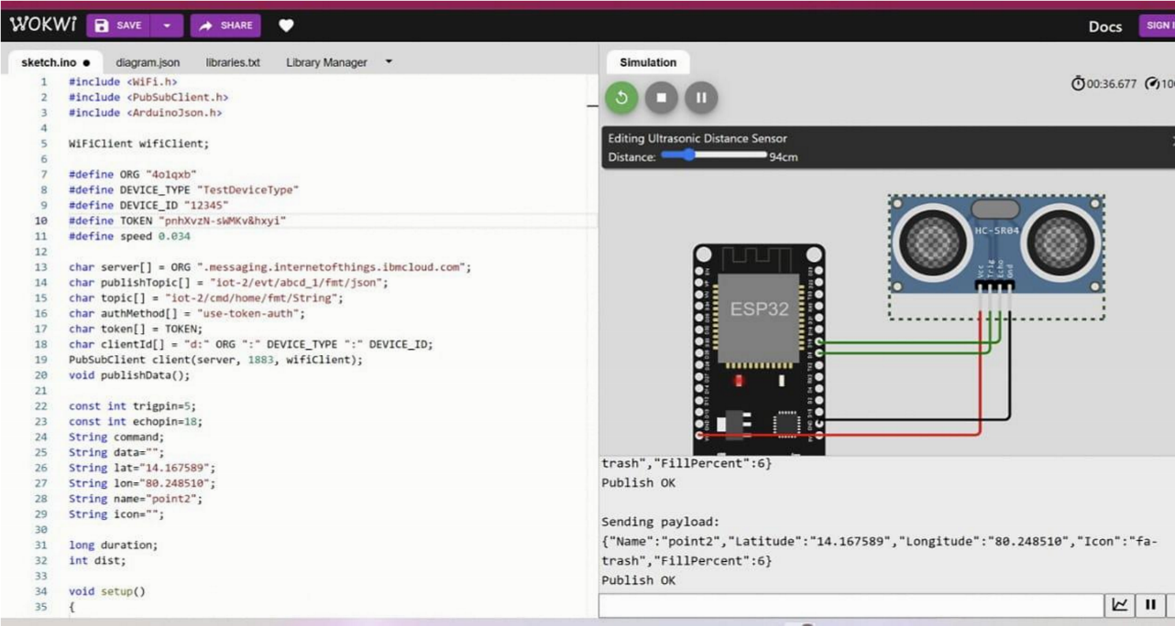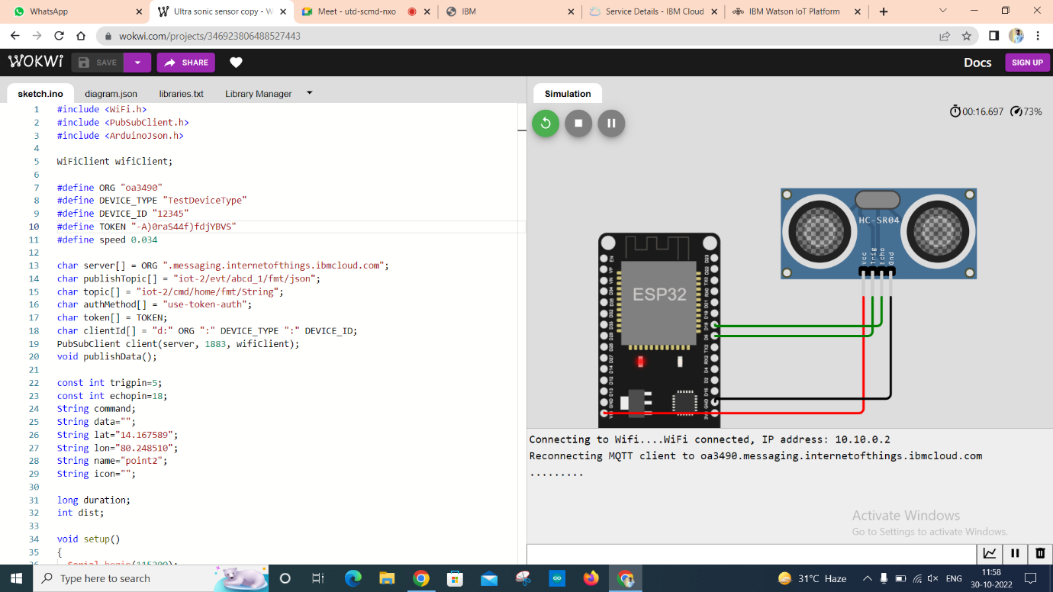

**Output :( IBM Cloud)**

